
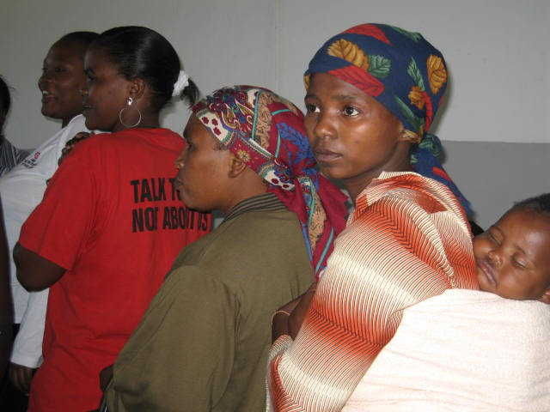


UCT Demonstration of Support for Abahlali
Date: 14 October

Time: 1:00pm
Venue: Jammie Plaza

Supported by Students for Law and Social Justice, Social Justice Coalition-UCT, History and Current Affairs and UCT Student-Worker Alliance

