Monday, 21 August 2006
Press Release 4 from the Motala Heights Development Committee (affiliated to Abahlali baseMjondolo)

CORRUPTION AND ARMED INTIMIDATION AS MOTALA HEIGHTS EVICTIONS CRISIS DEEPENS

On Saturday 17 June 2006 Ward Councillor Derek Dimba arrived at the Motala Heights settlement in Pinetown with municipal officials and 5 car loads of municipal security guards to mark out shacks that would then be destroyed by the militarised police Land Invasions Unit. They had probably chosen the Youth Day weekend thinking that many people would be away at their rural homes. They were wrong. The community was able to mobilise quickly and see off this first threat.

The Motala Heights Development Commitment spent the next day gathering detailed information from residents and preparing affidavits and were at the Legal Resources Centre first thing on Monday morning. They then moved on the Municipal offices in New Germany where they were able to win an unscheduled emergency meeting with Mr. Geoff Nightingale. Nightingale confirmed that the Municipality planned to move 63 families with ‘numbers’ to a new housing development at Nazareth Island and to evict the other residents. The Council’s ‘one shack = one house’ policy means that many families who are sharing shacks face eviction with no prospect of relocation. Nightingale also confirmed that Cllr Dimba had asked the Municipality to immediately destroy all new structures that had been erected. The eThekwini Municipality does not allow the construction of new shacks or the expansion or development of existing shacks. The Development Committee pointed out that all the new shacks and developments (all well made wooden cabins) had been built by long standing residents who needed more space for growing children, had got married, wanted to move out of over crowded shared shacks after finding work and so on.

On Women’s Day, 9 August 2006, Cllr Dimba returned with pistol holstered to each hip and flanked by his usual cohort of armed men. He summoned the community to a meeting where he began by gesturing to his weapons and promised to ‘chase away’ named individuals on the democratically elected committee. He then said, in a chilling echo of high apartheid language, that people in shacks without numbers would have to ‘hamba khaya’ and ‘go back where they came from’. He said that after those people with numbers were relocated to Nazareth Island on 27 August 2006 the houses of the others would be demolished.

The Motala Heights settlement lies amongst the gum tress on the hill behind Motala Heights suburb which is, in turn, just behind the many factories in Pinetown’s industrial area. It was founded in 1992 by Mr. Richard Nzuza and the residents mostly come from Zululand, the Eastern Cape and Ixopo although some are from as far away as the Free State. Almost everyone came here to work or to reunite families divided by migrant labour. Most of the men work in the nearby factories and most of the women work in the houses in the adjacent suburb. There is a school, clinic, library and shops within walking distance which means that living in Motala Heights has the tremendous benefit of radically cutting down the time and money that poor people usually have to spend on transport.

There are almost 300 shacks in the settlement. The land is owned by local tycoon Ricky Govender who has developed cottages for rent on adjacent land and also owns the local bottle store and supermarket as well as a trucking company amongst other businesses. It is rumoured that he has many government contracts too. People in the Motala Heights settlement have excellent relationships with most of the residents in formal houses. They often work in their homes and share the same taxis. The local taxi boss, just known as Leon, is widely respected in the settlement. But the conflict with the Govender family goes back to 1997 when Ricky’s father, Harry, used industrial earth moving equipment to dig up the road leading into the settlement. The shack dwellers responded by building their own road with their own tools and labour. It is now widely believed that Govender is aiming to extend his private development, including housing and a petrol station, up the hill in a large private development after the shack dwellers have been evicted. Cllr Dimba appears to report directly to Govender usually visiting him before and after his armed visits to the Motala Heights Settlement. The Housing Department have told the Motala Heights Committee that they cannot buy the land from Govender as he is demanding a completely unreasonable price. The Community is demanding the expropriation of the small section of Govender’s large land holding where they have built their community in order that there can be an upgrade where people are already living.

The 63 families scheduled to move to Nazareth Island would rather stay in Motala Heights where they are close to work, schools, the local clinic, shops and the other benefits of being near to Pinetown and where they are part of an established community. Many amongst them refused to register for the tiny badly built houses in Nazareth Island for these reasons and many also refused to register in solidarity with others who don’t have ‘a number’ and face eviction without relocation. Numerous people in the community allege that the ‘numbers’ of the people that didn’t register have been sold off to people from elsewhere, especially KwaMashu The Committee is currently making the arrangements to pursue vigorous legal action against this alleged corruption. The more than 200 families who now face eviction and the destruction of their community, their houses and their access to urban opportunity are determined to resist eviction by all means. They will explore all legal options but will also use mass mobilisation and will draw on the support of shack dwellers elsewhere to defend their homes, their community and their right to live near the city. The resistance is being organised by the democratically elected and mandated Motala Heights Development Committee which is affiliated to the Abahlali baseMjondolo movement.

For comment on the particular situation confronted by Motala Heights please contact the following members of the Motala Heights Development Committee:

Mr Bhekuyise Ngcobo 0769212891, Chair
Mrs Lewisa Motha 0781760088, Deputy Chair
Mr Alson Mkhize, 0827608427
Mr Sizwe Nkwanyana 0839951351

For comment on the general situation confronted by shack dwellers in the eThekwini Municipality as they face the onslaught of the Municipality’s looming mass evictions and forced removals under its World Bank/UN designed ‘slum clearance’ programme that aims to ‘clear the slums by 2010’ please contact the following members of the Abahlali baseMjondolo secretariat.

Mr S’bu Zikode 0835470474, Chair
Mr Mnikelo Ndabankulu 073565241, Media Liason
Ms Fikile Nkosi 0842501446

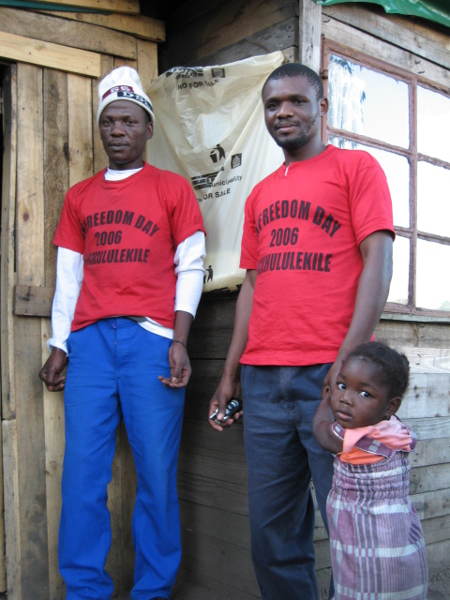

Mzuyanda Ngthobane (24), Nkosinathi Gabella (28) and Slethiwe Ngcobo (3) all confront eviction from their home in the Motala Heights Settlement. They are pictured outside Mr Ngthobane’s home. Mr Ngthobane is a long time resident of Motala Heights and has just built his own wooden home after years of sharing a shack with 6 others.

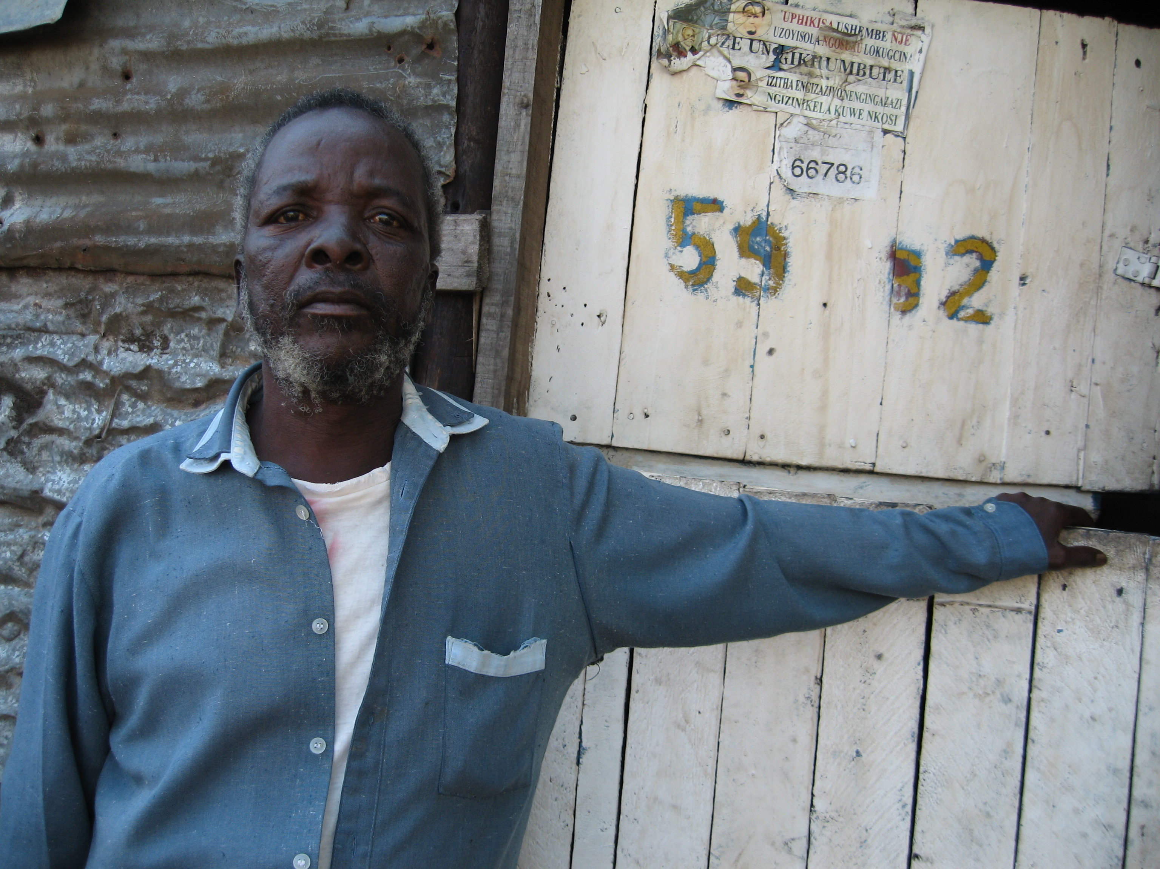

Mr. Richard Nzuza, founder of the Motala Heights Settlement.
“I will not be moved. I will die here.”

