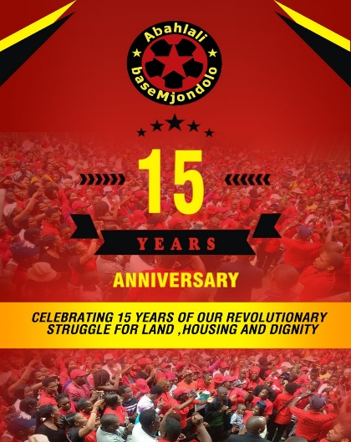

Abahlali baseMjondolo Movement SA Seminar on 15 Years
Of
Revolutionary Journey under the theme Sifike Kanjani La?
(How have we come here?)

03 October 2020

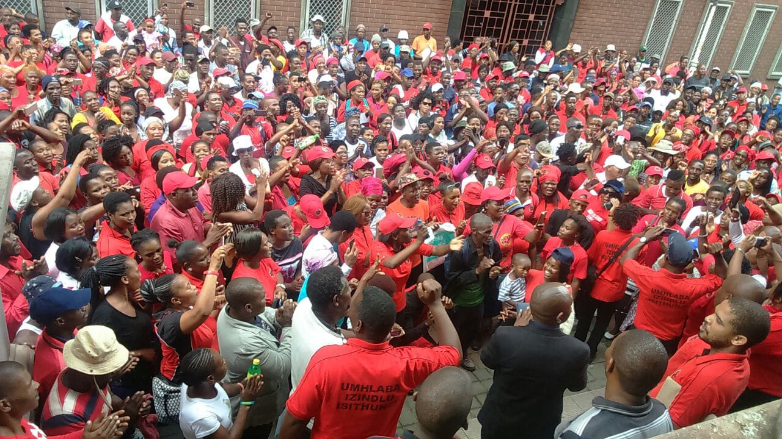
08h00 - 08h30 | Tea | All
08h30 – 09h00 | Watching Abahlali Documentary | All
09h00 – 09h10 | Abahlali baseMjondolo Choir | All
09h10 – 09h20 | Welcoming  Handover to Programme Director | General Secretary  Mr Ntsenge
09h20 – 09h30 | Introduction and Purpose of the Day | ABM President
09h30 – 09h40 | Cde Speaker Sharing Experience | Zandile Nsibande
09h40– 09h50 | Cde Speaker Sharing Experience | Simthembile Zikode
09h50 – 10h00 | Cde Speaker Sharing Experience | Maphiwe Gasela
10h00– 10h10 | Cde Speaker Sharing Experience | Noluthando Bazikise
10h10 – 10h30 | Discussion from the ground | All
10h30 – 10h40 | Cde Speaker Sharing Experience | Mazwi Nzimande
10h40 – 11h00 | Cde Speaker Sharing Experience | Grahm
11h00 – 11h10 | Lindelani Choir | Lindelani Choir
11h10 – 11h40 | Open Discussion | All
11h40 – 11h50 | Cde Speaker Sharing Experience | G.P
11h50 – 12h00 | Cde Speaker Sharing Experience | M.P
12h00 – 13h00 | Lunch Time | All
13h00 – 13h10 | Choir | Lindelani
13h10 – 13h20 | Cde Speaker Sharing Experience | Cde Mavuso
13h20 – 14h00 | Cde Speaker Sharing Experience | Guest Speaker Cde Richard
14h00 – 14h30 | Open Discussion from the Ground | All
14h30 – 14h50 | Summary Review | Cde Richard
14h50 – 15h00 | Vote of Thanks | National Chairperson

